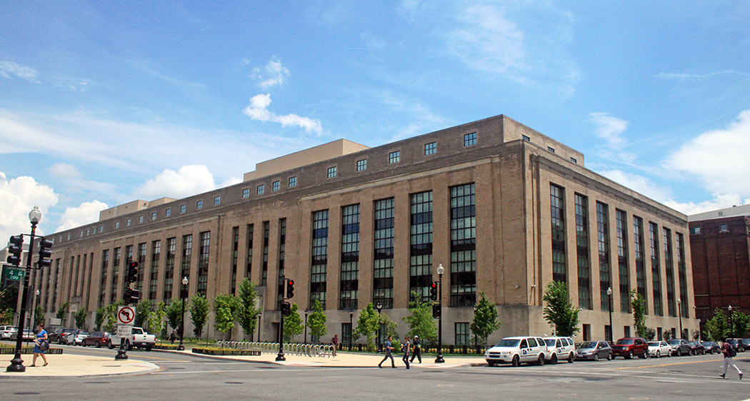

[Event Title Here]
Wednesday, January 31st
10am to 1pm (EST)
Switzer Bldg. Room 9999
Audio Dial-in: (555) 555-0000 Passcode: 0000000
Web Conference: hhs.adobeconnect.com/XXXXXXXXXX
[Add in a brief 1-2 sentence description of the event here. To replace the photo, delete it and select the Insert tab, then click Picture. Crop or proportionally resize the picture to fit the flyer. Save the file to PDF before publishing.]
[For more information call John Johnson: (555) 555-XXXX
For technical support call Jan Janson: (555) 555-XXXX]

